Chapter 2 Homework Problems

Problem 2.1

Determine the x and y components of the force vector shown below.

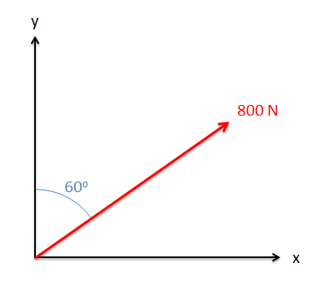

Solution: Fx=692.8 N, Fy=400N

Problem 2.2

Determine the x, y, and z components of the vector shown below.

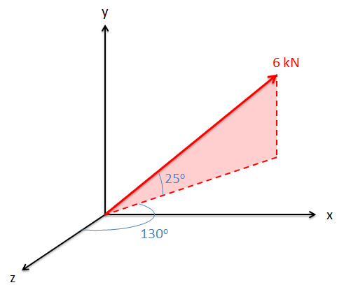

Solution: Fx=4.17 kN, Fy=2.54 kN, Fz=-3.50 kN

Problem 2.3

Determine the x and y components of the sum of the two vectors shown below.

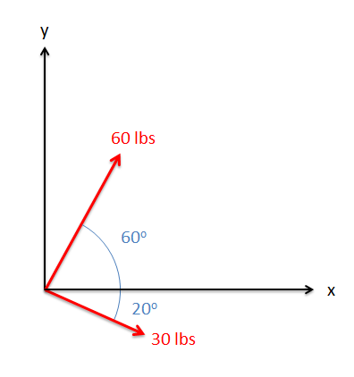

Solution: Ftotal = [58.2, 41.7] lbs

Problem 2.4

There are two forces acting on a barge as shown below (F1 and F2). The magnitude and direction of F1 is known, but the magnitude and direction of F2 is not. If the sum of the two forces is 600 N along the x-axis, what must the magnitude and direction of F2 be?

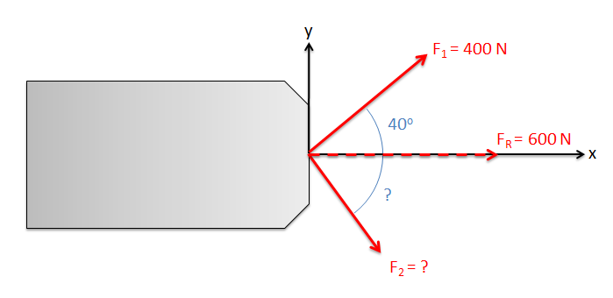

Solution: F2=390.3 N at 41.2o below the x axis

Problem 2.5

A 30 kg barrel is sitting on a handcart as shown below. Determine the normal forces at A and B.

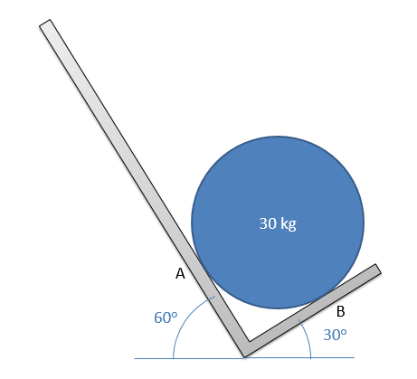

Solution: FA = 147.7 N, FB = 255.9 N

Problem 2.6

A .25kg ball rolls into a corner as shown below. Assuming the surfaces are smooth (no friction), determine the normal forces at A and B.

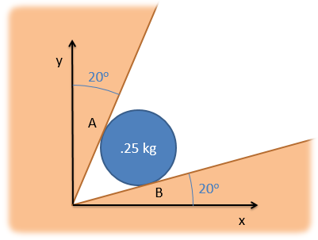

Solution: FA = 1.09 N, FB = 3.01 N

Problem 2.7

A 50 kg truck engine is lifted using the setup shown below. Assuming that the pulleys shown in the diagram are frictionless, what force (P) must be applied to the cable to hold the engine in the position shown below with d = 1m? (Hint: Draw a free body diagram of the pulley supporting the engine block)

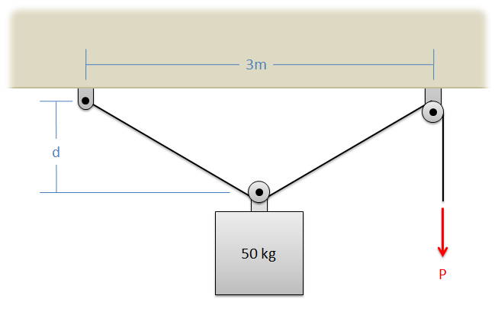

Solution: P = 442.1 N

Problem 2.8

Three equally sized cylinders with equal mass are stacked in a groove as shown below. Determine all forces acting on cylinder C and show them in a diagram.

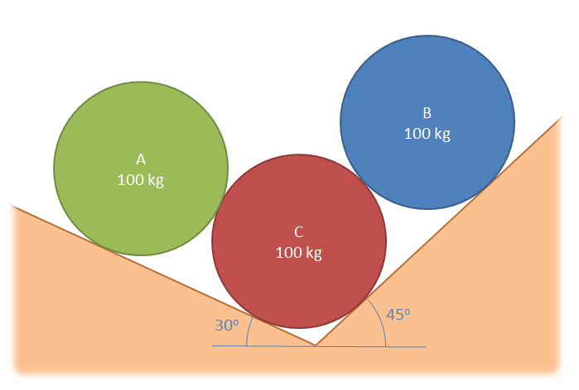

Solution: FAC = 490.5 N, FBC = 693.7 N, FC1 = 1304.6 N, FC2 = 829.7 N, Fg = 981 N

Problem 2.9

A hot air balloon is tethered as shown below. Assuming that the balloon is pulling upward with a force of 900 lbs, determine the tension in each of the cables.

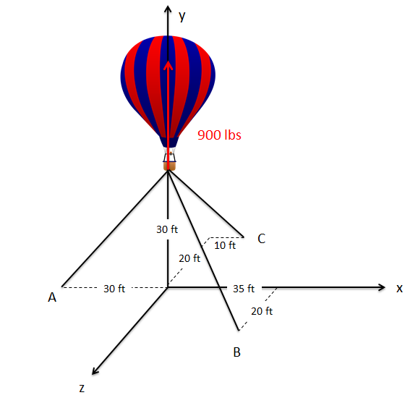

Solution: TA = 545.5 lbs, TB = 430.7 lbs, TC = 320.7 lbs